CF Case Study #02 – EdTech – Identify purpose and intended outcomes for the session.

# Case Study

A new scrum master at a growing EdTech company has approved you as an experienced Scrum Master to support in improving her facilitation skills as a Scrum Master. She has observed that she has challenges in identifying the purpose and intended outcomes for her session. She is seeking coaching on how to structure / frame the identified purpose and intended outcome for a session

# Solution

## Situation

A new scrum master at a growing EdTech company has approved you as an experienced Scrum Master to support in improving her facilitation skills as a Scrum Master. She has observed that she has challenges in identifying the purpose and intended outcomes for her session. She is seeking coaching on how to structure / frame the identified purpose and intended outcome for a session

## Task

Coach a growing Scrum Master on how to structure / frame an identified purpose and intended outcome for a session

## Action

The key actions taken:

1. Create a coaching working agreement
2. Coached on the use of Facilitation Canvas for structuring and framing the identified purpose and intended outcomes for a session
   1. Purpose
      1. What are we looking to achieve?
   2. Outcomes
      1. What are the outcomes needed to make the session a success?
   3. People
      1. Who needs to be part of this session and what is their role?
   4. Inputs
      1. What inputs need to be brought along to the session for background and discussions?
   5. Agenda
      1. How will we structure the session?
   6. Environment
      1. How will you create the environment in which participants can achieve their intended purpose and desired outcome?
   7. Outputs
      1. What outputs / deliverables are expected to be produced in the session?
   8. Pitfalls
      1. What could hinder the session
3. Coached on how to fill Facilitation Canvas individually, with Scrum Team and with stakeholders using Miro

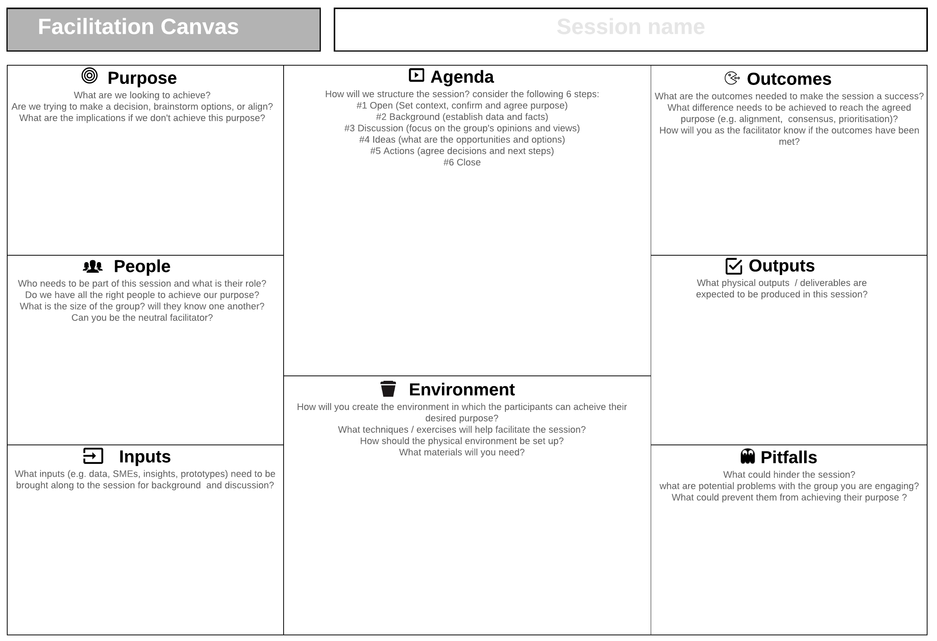

Figure 1 - Facilitation Canvas

## Outcomes

At the end of the Facilitation Coaching Sessions,

1. New Scrum Master gained new understanding on how to collaboratively set the intended purpose and desired outcome of a session using Facilitation Canvas
2. New Scrum Master gained confidence in facilitation session especially technical session with challenging stakeholders with unclear desired outcome
3. New Scrum Master acknowledge personal growth as a facilitator

Reference:

1. Facilitation Canvas - <https://nomad8.com/articles/facilitation-canvas>

Facilitation Canvas - <https://miro.com/miroverse/facilitation-canvas/?social=copy-link>